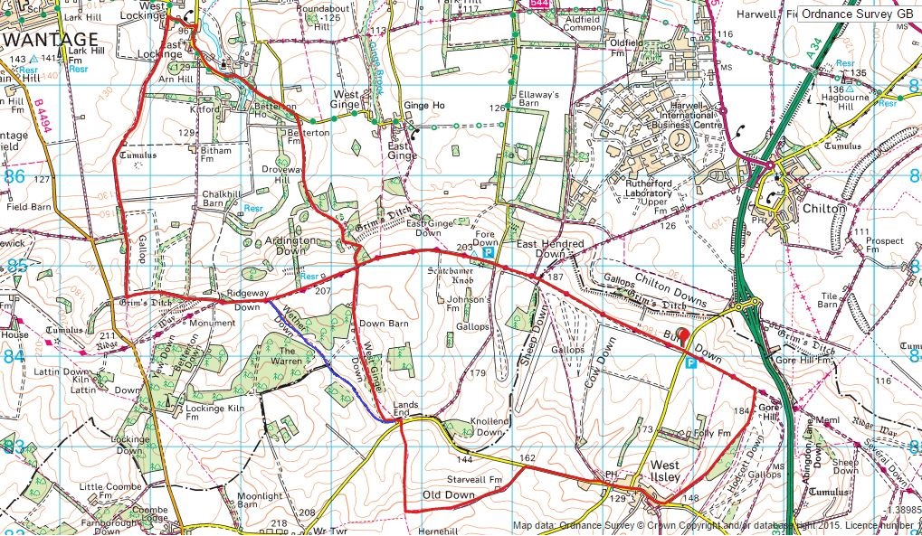
Route 22km Optional Gallop in Happy Valley

